Contract Application Blocked

by Java Security

Product | Gimmal Contract
Product Version | 6.9.x
Issue | After updating JAVA on a workstation, Gimmal Contract throws an "Application Blocked by Java Security" message, handicapping the user from viewing, editing, and performing various tasks in the application.
Root Cause | Gimmal Contract URL may be missing or incorrect in the JAVA Exception Site List.
Resolution | To resolve, update the following JAVA settings in Control Panel. NOTE: This assumes the user is part of the ucf_file_transfer role in the Contract application.  - Ensure Security level is set to High. Add the URL to the Exception Site List in Java Security settings and click OK:  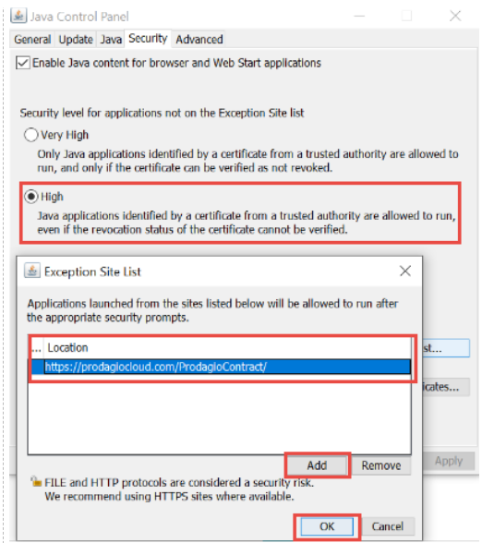  - Select Restore Security Prompts and click OK:  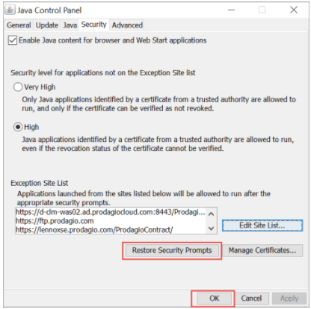  - When logging into the application, you may be prompted to allow Java to run, select "Run"  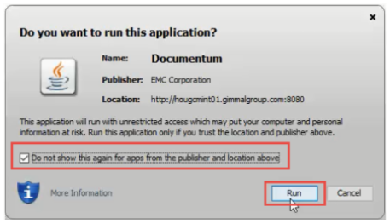  - Proper JAVA functionality should now be restored for the application.

